**1. Reading Assignment: A Short History of Java**

* **Task**: Read about the history and development of Java.
* **Link**: <http://sunsite.uakom.sk/sunworldonline/swol-07-1995/swol-07-java.html>

*Java was created by James Gosling and his team at Sun Microsystems in 1995, initially intended for interactive television. However, it evolved into a versatile language due to its portability, object-oriented structure, and robustness. Java gained popularity quickly because of its "write once, run anywhere" capability, supported by the Java Virtual Machine (JVM). It revolutionized the web with applets in the early days and has since grown into a key language for enterprise applications, Android development, and cloud computing.*

**2. Reading Assignment: Java Language Features**

* **Task**: Learn about the main features of Java.
* **Link**: <https://javaalmanac.io/features/>

*Java is known for its platform independence, made possible by the JVM, which allows Java programs to run on any device with a JVM installed. It is an object-oriented language, promoting modular, reusable code. Java emphasizes security, with features like the security manager and bytecode verification. Its simplicity and syntax, similar to C++, make it accessible, while features like automatic garbage collection enhance robustness. Multithreading and rich APIs further extend its usability for various applications*.

**3. Reading Assignment: Which Version of JDK Should I Use?**

* **Task**: Find out which JDK version is right for you.
* **Link**: <https://whichjdk.com/>

*The best JDK version for most users is usually the latest Long-Term Support (LTS) version, such as JDK 17, which offers stability and extended support. LTS versions receive regular updates and security patches, making them suitable for production use. Non-LTS versions, like JDK 21, include the latest features but are better suited for development and testing environments. If you need the latest language features, opt for the most recent release, but for most production uses, stick with LTS.*

**4. Reading Assignment: JDK Installation Directory Structure**

* **Task**: Understand the folder structure and files in the JDK installation.
* **Link**: <https://docs.oracle.com/javase/8/docs/technotes/tools/windows/jdkfiles.html>

*The JDK directory structure includes several key folders:*

* *bin: Contains executable files for development tools like javac, java, and javap.*
* *lib: Holds core libraries used by the JVM.*
* *include: Contains C/C++ header files for JNI (Java Native Interface).*
* *jre: A subset of the JDK, containing the runtime environment to execute Java applications. This structure helps manage Java development and runtime environments efficiently.*

**5. Reading Assignment: About Java Technology**

* **Task**: Read about the basics of Java technology and its components.
* **Link**: <https://docs.oracle.com/javase/tutorial/getStarted/intro/definition.html>

***About Java Technology****:  
Java technology is a blend of the Java programming language, the JVM, and a wide range of APIs that support development across multiple platforms. The language is designed to be simple, secure, and portable, while the JVM allows Java bytecode to be executed on any platform. Core Java APIs provide a foundation for developing desktop, web, and mobile applications. Together, these components enable developers to create robust, high-performance software solutions.*

**6. Coding Assignments**

1. **Hello World Program**: Write a Java program that prints "Hello World!!" to the console.

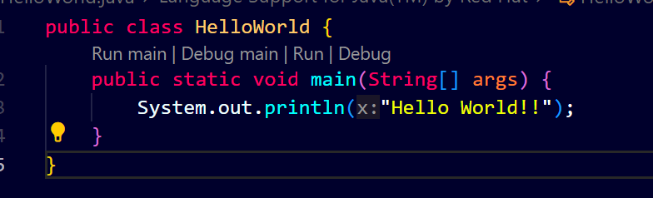



1. **Compile with Verbose Option**: Compile your Java file using the -verbose option with javac. Check the output.

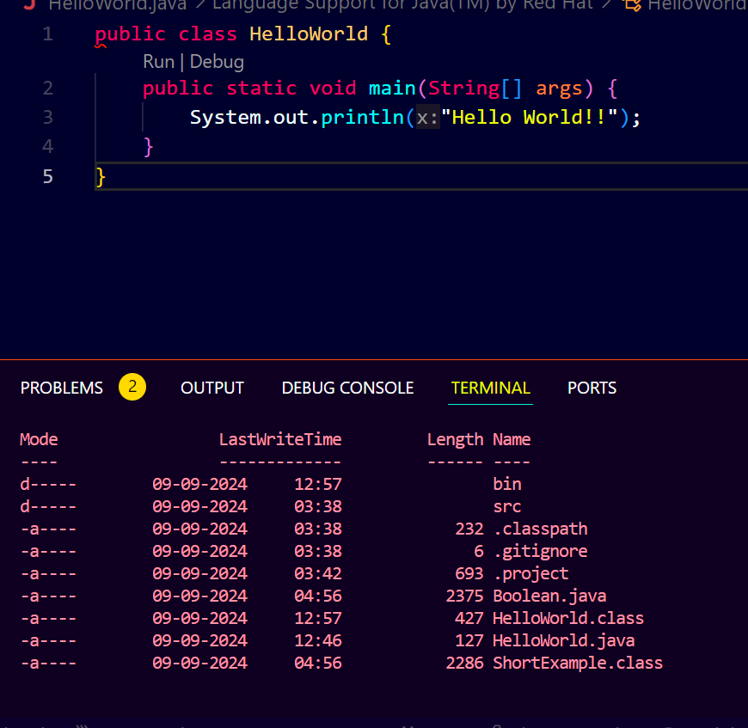

1. **Inspect Bytecode**: Use the javap tool to examine the bytecode of the compiled .class file. Observe the output.

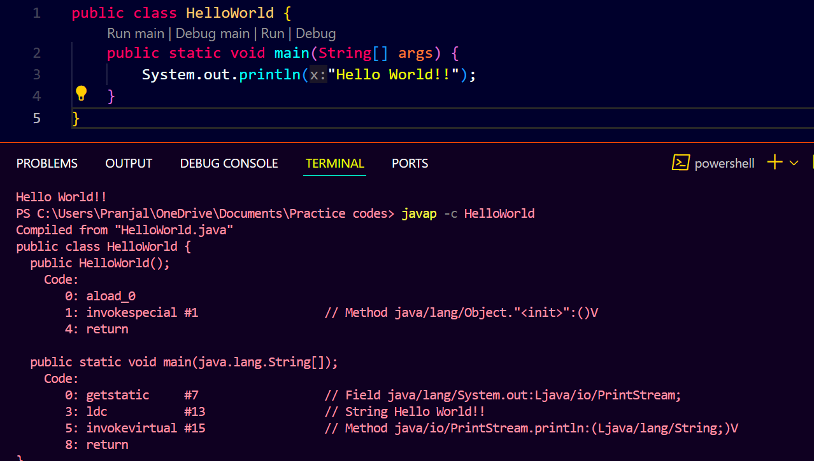

**7. Reading Assignment: The JVM Architecture Explained**

* **Task**: Learn about how the Java Virtual Machine (JVM) works.
* **Link**: <https://dzone.com/articles/jvm-architecture-explained>

***The JVM Architecture Explained****:  
The JVM is the engine that runs Java applications, converting bytecode into machine code via the Just-In-Time (JIT) compiler. It has a class loader system that loads classes into memory and an execution engine that handles instruction execution. The JVM also manages memory allocation and garbage collection, ensuring efficient use of resources. It provides a secure execution environment and isolates applications from the underlying operating system, enhancing security and stability.*

**8. Reading Assignment: The Java Language Environment: Contents**

* **Task**: Explore the content and features of the Java language environment.
* **Link**: https://www.oracle.com/java/technologies/language-environment.html

***The Java Language Environment****:  
The Java language environment encompasses everything needed to develop and run Java applications, including the language syntax, the JVM, and extensive libraries (APIs). It provides built-in support for object-oriented programming, exception handling, and multithreading. The environment is designed to be simple yet powerful, enabling developers to write high-quality, reusable code. Its robust set of APIs covers everything from data structures to networking, GUI development, and more.*